Date/  Name: __________________________________ Date: 2/24/20  Specials | Conduct Score | Homework | This Week….
Monday  2/24  Art | Score  _________  Parent Signature  __________ | - Read For 15 Minutes  - Reading Passage: read the passage and complete Day 1  - Read your spelling words two times each | Reading Focus: We will use this upcoming week to review many of the important reading strategies learned over the past quarter. We will review strategies for fluency, comprehension and accuracy. We will also spend time reviewing strategies for expanding vocabulary.
Tuesday  2/25  Music | Score  _________  Parent Signature  __________ | - Read For 15 Minutes  - Reading Passage: read the passage and complete Day 2 and Day 3  - Spelling: Write your spelling words 2 times each | 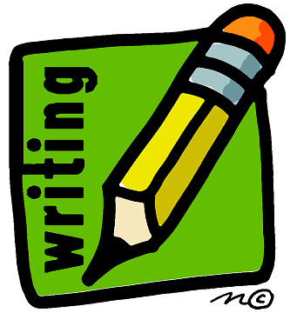 Writing Focus: We are publishing small moment stories this week. Students have been working on writing narratives while including strategies that have been added to our “Craft Chart”. Ezra Jack Keats has been our mentor over the past several weeks and the children have challenged themselves to apply these skills into their own stories!
Wednesday  2/26  PE | Score  _________  Parent Signature  __________ | - Read For 15 Minutes  - Math: “Find the Shape” sheet  - Reading Passage: read the passage and complete Day 4 and Day 5 | 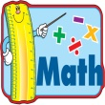 Math focus: In math students will continue to build understanding of two dimensional shapes by describing specific defining attributes for each shape. Students are using defining and non-defining attributes to describe these shapes. Specific vocabulary being used for our geometry unit include defining and non-defining attributes, closed and open figures, concave, angles/corners, and orientation to name a few!
Thursday  2/27  Media | Score  _________  Parent Signature  __________ | - Read For 15 Minutes  - Spelling: Write five sentences on the sheet provided and take a practice spelling test on the back of that sheet | Notes from the Teacher….  - Please be sure that reading and writing continues to be a daily routine even over track out. Keep a daily reading log of the title of each book and the minutes read. Create a goal and plan a reward if the goal is met by the end of track out! You may also want to keep a daily writing journal and have them write a minimum of 4 sentences about each day’s events.
Friday  2/28  Falcon Friday | Score  _________  Parent Signature  __________  Mrs. Bullock dbullock1@wcpss.net | No Homework!  - Homework Packet Due | Spelling Words:  night lie right tied tight  pie light high might tries  Tricky Words:  one lives

