Date/  Name: __________________________________ Date: 2/17/20  Specials | Conduct Score | Homework | This Week….
Monday  2/17  No School | Score  _________  Parent Signature  __________ | - Teacher Work Day  - No Homework | Reading Focus: We will be focusing on reading fluency and accuracy this week. Students should be paying close attention to the punctuation in order to know when to pause and take a breath. We will also continue to compare and contrast fiction and non-fiction books across a single topic while building new vocabulary related to a particular subject (expand vocabulary).
Tuesday  2/18  Music | Score  _________  Parent Signature  __________ | - Read For 15 Minutes  - Reading Passage: Read the passage and complete day 1  - Spelling: Read your spelling words two times each. Write your spelling words two times each. | 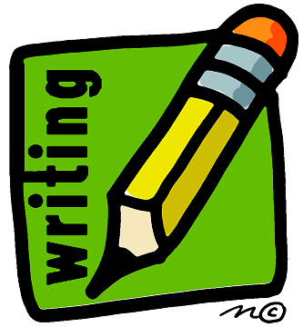 Writing Focus: We are currently closely examining other popular authors and creating a “craft chart” of all the specific strategies that we notice these famous authors using. Students are then being challenged to incorporate these strategies into their own writing!
Wednesday  2/19  PE | Score  _________  Parent Signature  __________ | - Read For 15 Minutes  - Reading Passage: Read the passage and complete days 2 and 3  - Math: Complete “Decade Numbers Journal Prompt  - Practice your spelling words | Math focus: Students will continue to explore and describe shapes using defining and non-defining attributes. We will focus on both one dimensional and three dimensional shapes. Students will name shapes and distinguish between defining and non-defining attributes. They will also create shapes with defining attributes.
Thursday  2/20  Media | Score  _________  Parent Signature  __________ | - Read For 15 Minutes  - Reading Passage: Read the passage and complete days 4 and 5  - Spelling: Write five sentences on the sheet provided and take a practice spelling test on the back of that sheet | Notes from the Teacher….  - Please be reminded that you must send in a note regarding any transportation changes that may take place. I am not permitted to send a student home a different way unless I am properly notified by a parent. Thank you for your understanding in this matter.
Friday  2/21  Falcon Friday | Score  _________  Parent Signature  __________  Mrs. Bullock dbullock1@wcpss.net | No Homework!  - Homework Packet Due | Spelling Words:  boat grow soap road know  low yellow float show coat  Tricky Words:  could are done

