Date/  Name: __________________________________ Date: 2/10/20  Specials | Conduct Score | Homework | This Week….
Monday  2/10  Art | Score  _________  Parent Signature  __________ | - Read For 15 Minutes  - Reading Passage: read the passage and complete Day 1  - Read your spelling words two times each | Reading Focus: Students will continue to explore with a variety of genres including fiction, non-fiction, poetry, and fairy tales. Students are reading books on a single topic across multiple genres and gathering information to share while working in their small “Reading Clubs”. We are also focusing on using our accuracy strategies independently and on expanding our vocabulary while reading a variety of books on a single topic.
Tuesday  2/11  Music | Score  _________  Parent Signature  __________ | - Read For 15 Minutes  - Reading Passage: read the passage and complete Day 2 and Day 3  - Spelling: Write your spelling words 2 times each | 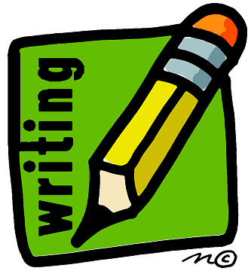 Writing Focus: We are continuing to use authors as mentors to become even better writers. Students are writing small moments while applying strategies and techniques that other authors use. The class is creating a chart of noted strategies seen in books written by Ezra Jack Keats and other famous authors, and are then working hard to incorporate those strategies into their own writing.
Wednesday  2/12  PE | Score  _________  Parent Signature  __________ | - Read For 15 Minutes  - Math: “Tell Ten More or Ten Less” sheet  - Reading Passage: read the passage and complete Day 4 and Day 5 | 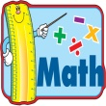 Math focus: Students are building fluency strategies for adding single digit numbers quickly and accurately. Students are also applying place value understanding while adding double digit numbers. Finally the concept of ten more and ten less has been a focus over the past week.
Thursday  2/13  Media | Score  _________  Parent Signature  __________ | - Read For 15 Minutes  - Spelling: Write five sentences on the sheet provided and take a practice spelling test on the back of that sheet | Notes from the Teacher:  - We will have a Valentine’s Day Celebration for the students only on Friday (2/14) afternoon. I have sent home a list of our classmates in order to prepare cards. Please be sure that the cards are sent in on Friday so that they can pass them out during our celebrations.
Friday  2/14  Valentine’s  Day! | Score  _________  Parent Signature  _________  Mrs. Bullock dbullock1@wcpss.net | No Homework!  - Homework Packet Due | Spelling Words:  wait day train tail play  say paint staying afraid waiting  Tricky Words:  saw give

