Date/  Name: __________________________________ Date: 1/27/20  Specials | Conduct Score | Homework | This Week….
Monday  1/27  Art | Score  _________  Parent Signature  __________ | - Read For 15 Minutes  - Begin working on your Map Project (see instructions that are provided in their Daily Folder)  - Study your spelling words | Reading Focus: Students have been working hard over the past several weeks applying the many reading strategies taught throughout the school year on an independent basis. These strategies focus on building reading comprehension, accuracy and fluency.
Tuesday  1/28  Music | Score  _________  Parent Signature  __________ | - Read For 15 Minutes  - Work on your Map Project  - Study your spelling words | 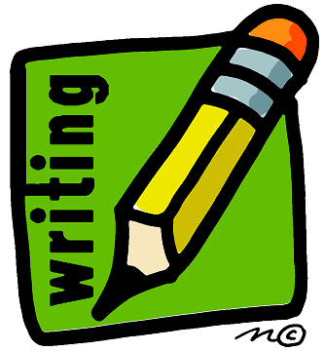 Writing Focus: We will be finishing our unit on “all about” writing this week. Students have been writing informational pieces on a specific topic. These pieces include an opening sentence, at least three true facts about the topic, and a closing sentence. Students will be publishing one of their pieces this week!
Wednesday  1/29  PE | Score  _________  Parent Signature  __________ | - Read For 15 Minutes  - Work on your Map Project  - Study your spelling words | 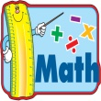 Math focus: In math we will continue our focus on two digit numbers and on place value. Students are using their understanding of place value (tens and ones) to assist them in adding two digit numbers.
Thursday  1/30  Media | Score  _________  Parent Signature  __________ | - Read For 15 Minutes  - Finish your Map Project  - Study your spelling words | Notes from the Teacher….  - Please be sure that your son or daughter is studying nightly for the weekly spelling test. The words are becoming increasingly more difficult and require more studying time. They should also practice the two sentences on a regular basis.  - Please let me know if you have any questions regarding the Map Project that is due this Friday.
Friday  1/31  Falcon Friday | Score  _________  Parent Signature  __________  Mrs. Bullock dbullock1@wcpss.net | No Homework!  - Map Project Due | Spelling Words:  see help keep next these  need resting sleep feelings green  Tricky Words:  their soon

