Date/  Name: __________________________________ Date: 1/6/20  Specials | Conduct Score | Homework | This Week….
Monday  1/6  Art | Score  _________  Parent Signature  __________ | - Read For 15 Minutes  - Reading Passage: read passage and complete day 1  - Read your spelling words two times each | Reading Focus: We will continue to focus on reading strategies during the next several weeks. Students will learn how they can be their own teachers when they work hard to figure out tricky words. Many strategies will be revisited and new ones will be introduced to help students with their accuracy, fluency and comprehension.
Tuesday  1/7  Music | Score  _________  Parent Signature  __________ | - Read For 15 Minutes  - Reading Passage: read passage and complete days 2 and 3 | 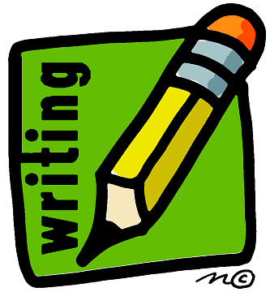 Writing Focus: Students will continue to work on writing All About books this upcoming week. We are currently working on writing our first one as a whole class. This book is titled All About Me!
Wednesday  1/8  PE | Score  _________  Parent Signature  __________ | - Read For 15 Minutes  - Reading Passage: read passage and complete day 4  - Math: complete “Teamwork” sheet | Math focus: In math students are building strategies to solve a variety of word problems. These word problems include adding and subtracting within 20 and missing addends. Students are asked to show their work with pictures, words, or numbers and are expecting to participate in math talk with their peers.
Thursday  1/9  Media | Score  _________  Parent Signature  __________ | - Read For 15 Minutes  - Reading Passage: read passage and complete day 5  - Spelling: “Red, Write, and Blue” sheet | Notes from the Teacher….  - If you are a parent volunteer during our literacy centers and are able to continue volunteering during this next quarter, please begin coming at 12:45 on your designated day. Your help during this time of our day is greatly appreciated!  - Please be sure that your son or daughter is beginning this second half of the school year with strong work habits. They should come to school prepared each day, read nightly at home, and complete their homework in a timely manner. Please also be sure that they are studying their spelling words nightly as well.
Friday  1/10  Falcon Friday | Score  _________  Parent Signature  __________  Mrs. Bullock dbullock1@wcpss.net | No Homework!  - Homework Packet Due | Spelling Words:  rope bike five hope write  home ride close closing writing  Tricky Words:  would your o’clock

